Joe Brew

PHC 6053

Assignment 5

* For the multiple linear regression using Y = LNSBP and the predictors AGE, BMI, and **FEMALE**create:
  + histogram of the residuals
  + 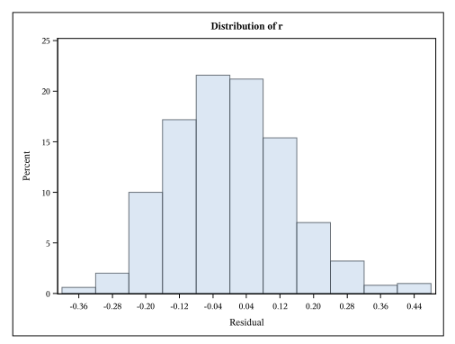
  + 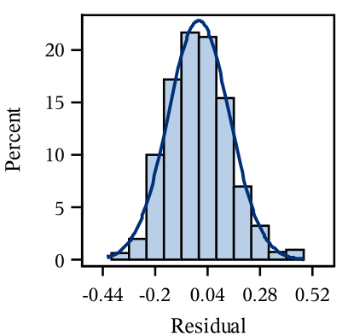
  + qq-plot of the residuals
  + 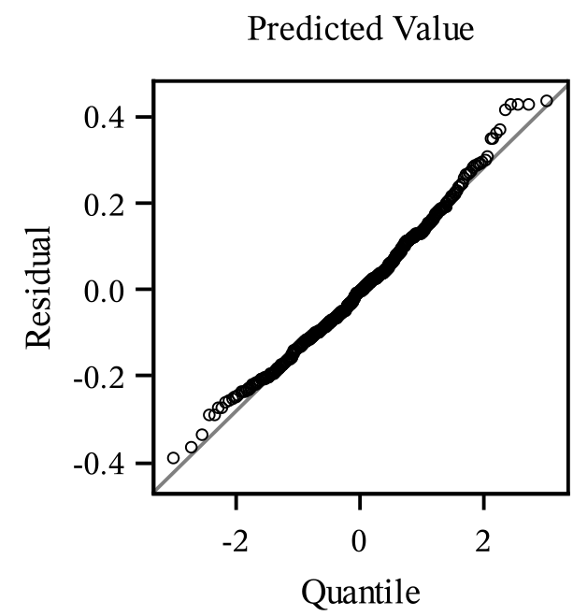
  + scatterplot of the residuals vs. EACH PREDICTOR (3 graphs)
  + 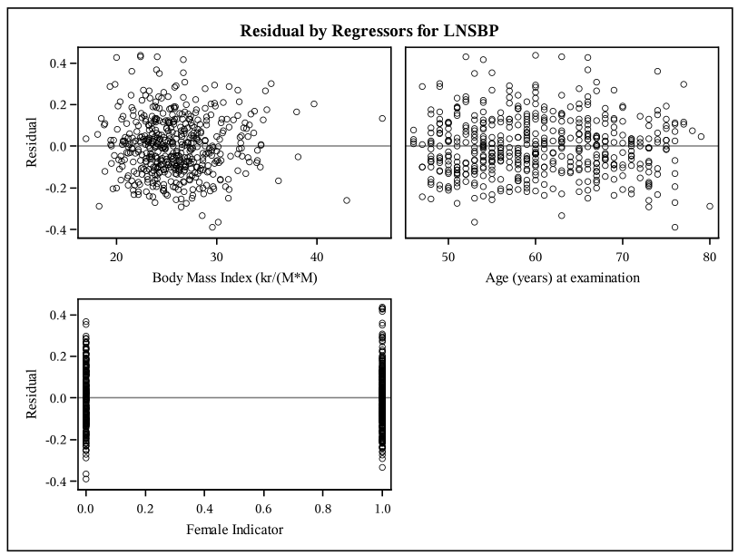
  + scatterplot of residuals vs. predicted values.
  + 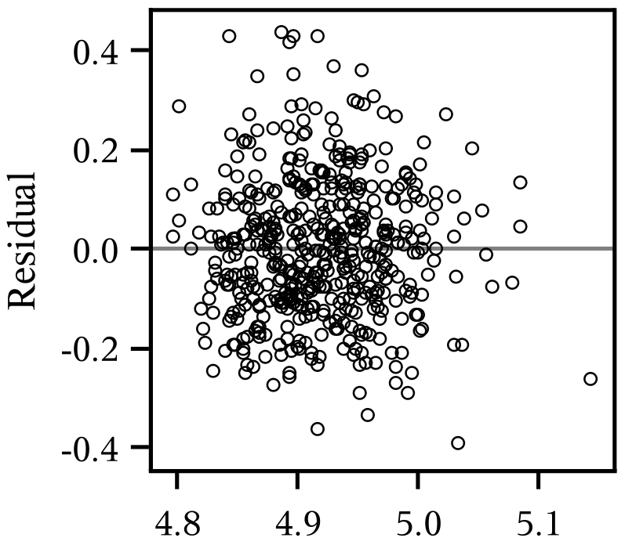

The order of the plots within this part is not important as long as they are all together for this regression.

These plots can be created in any manner as long as they are full-sized plots.  SAS users **cannot**include the panel display but can use the PLOTS(unpack) = ALL option as one way to unpack these graphs.

* Construct the following scatterplots labeled (grouped) by gender with loess curves for each gender
  + Y = LNSBP vs. X = AGE grouped by gender (you can use any coding of gender)
  + Males:
  + 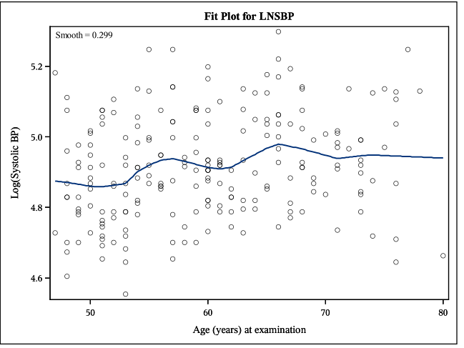
  + Females:
  + 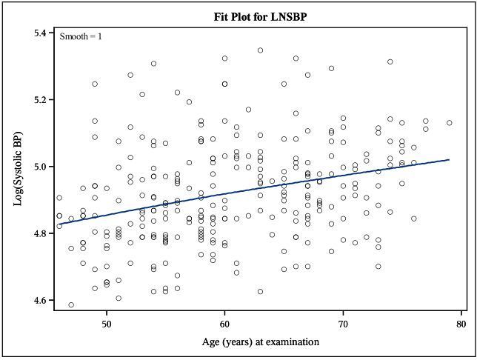
  + Y = LNSBP vs. X = BMI grouped by gender (you can use any coding of gender)
  + Males:
  + 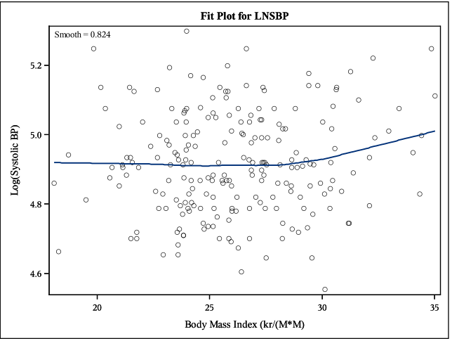
  + Females:
  + 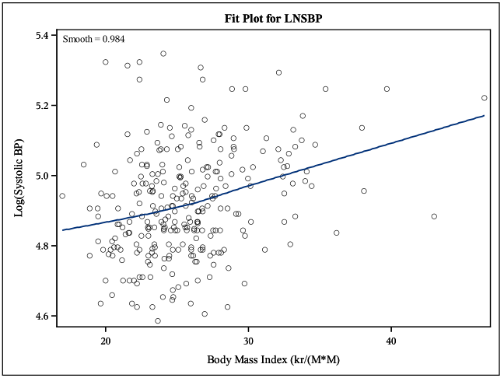
  + Y = BMI vs. X = AGE grouped by gender (you can use any coding of gender)
  + Males:
  + 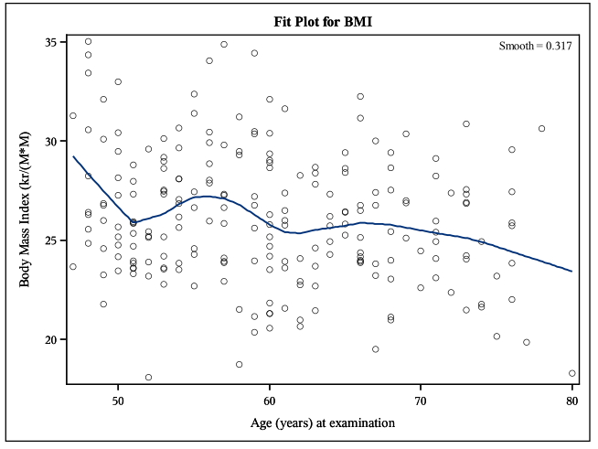
  + Females:
  + 